Sign Up:  
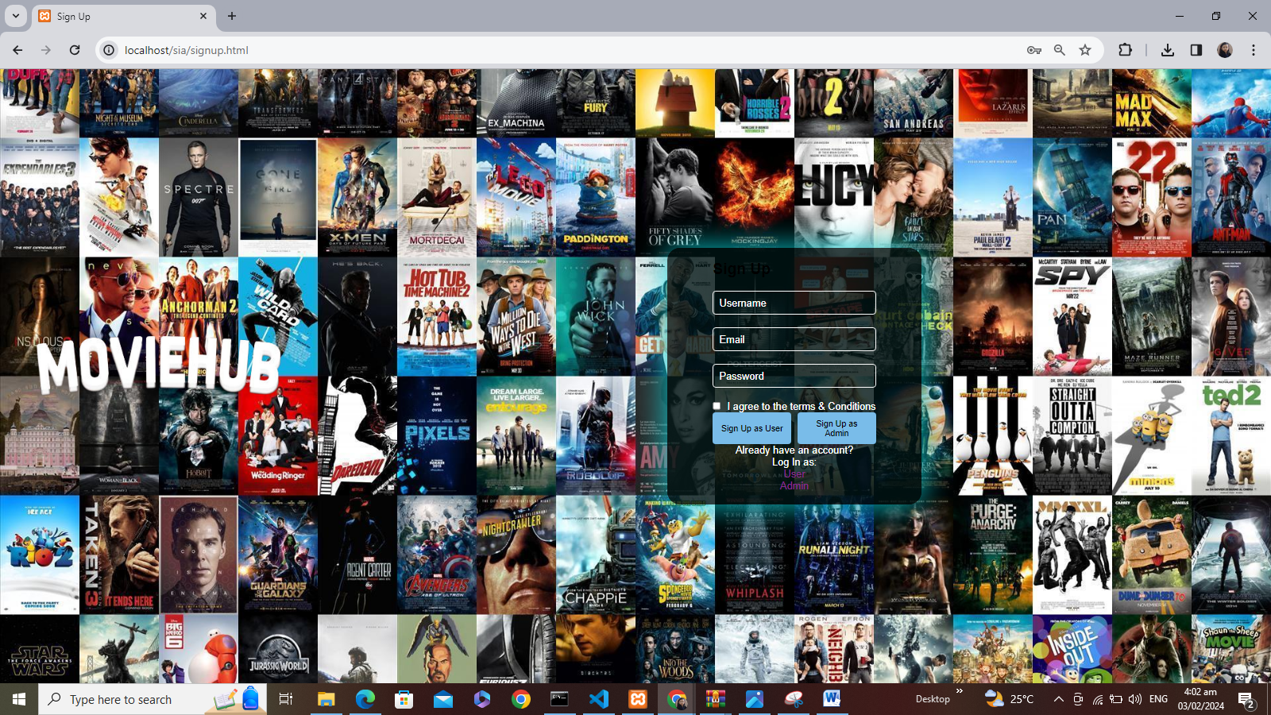  
  
Sign up as user:  
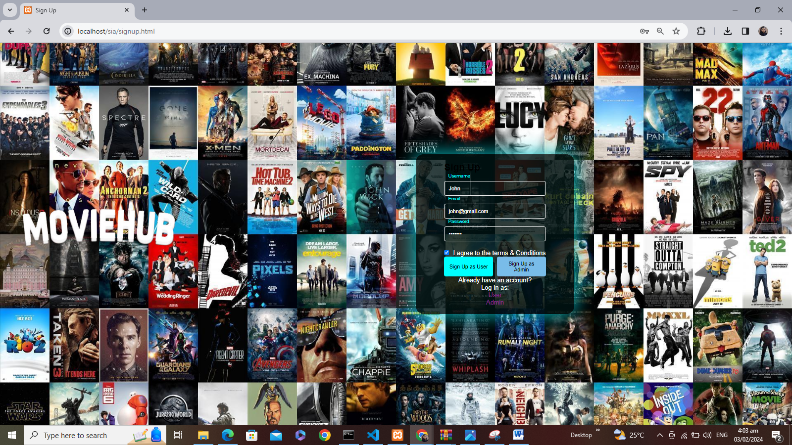

User Database:  
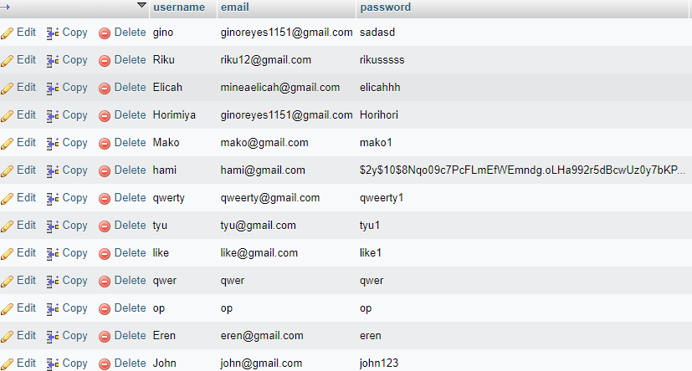

User Login:  
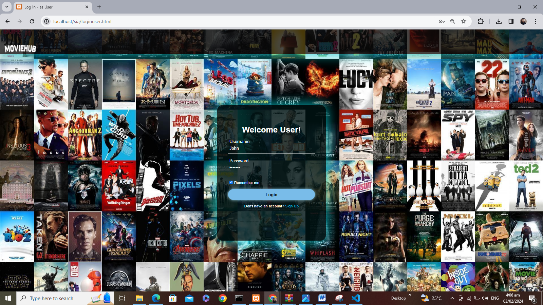

User Homepage:  
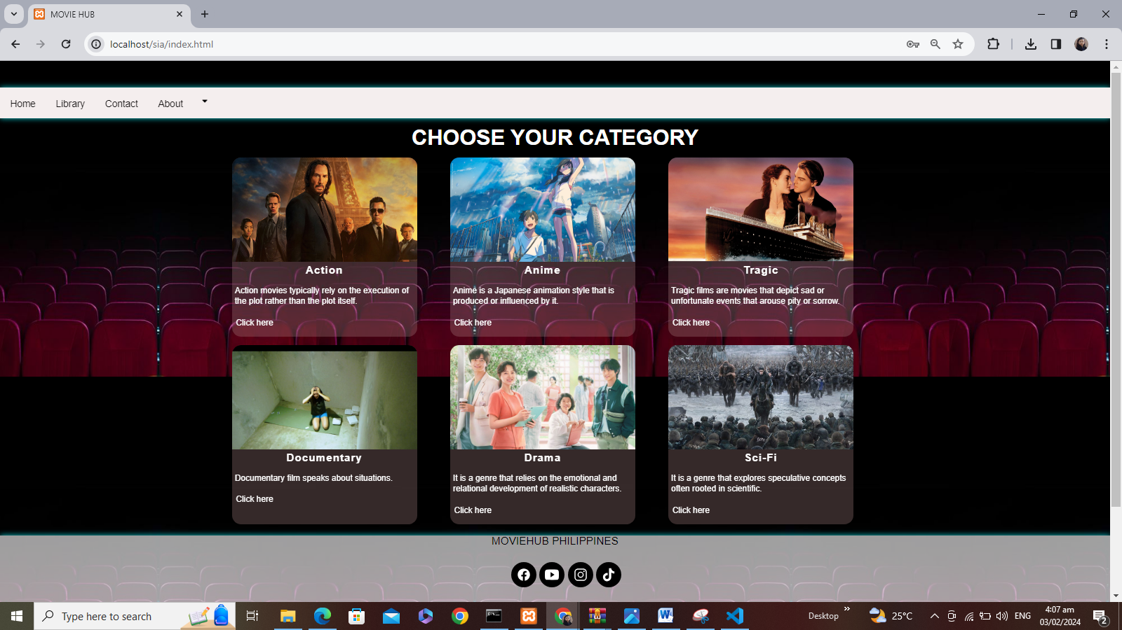

User Action Category:  
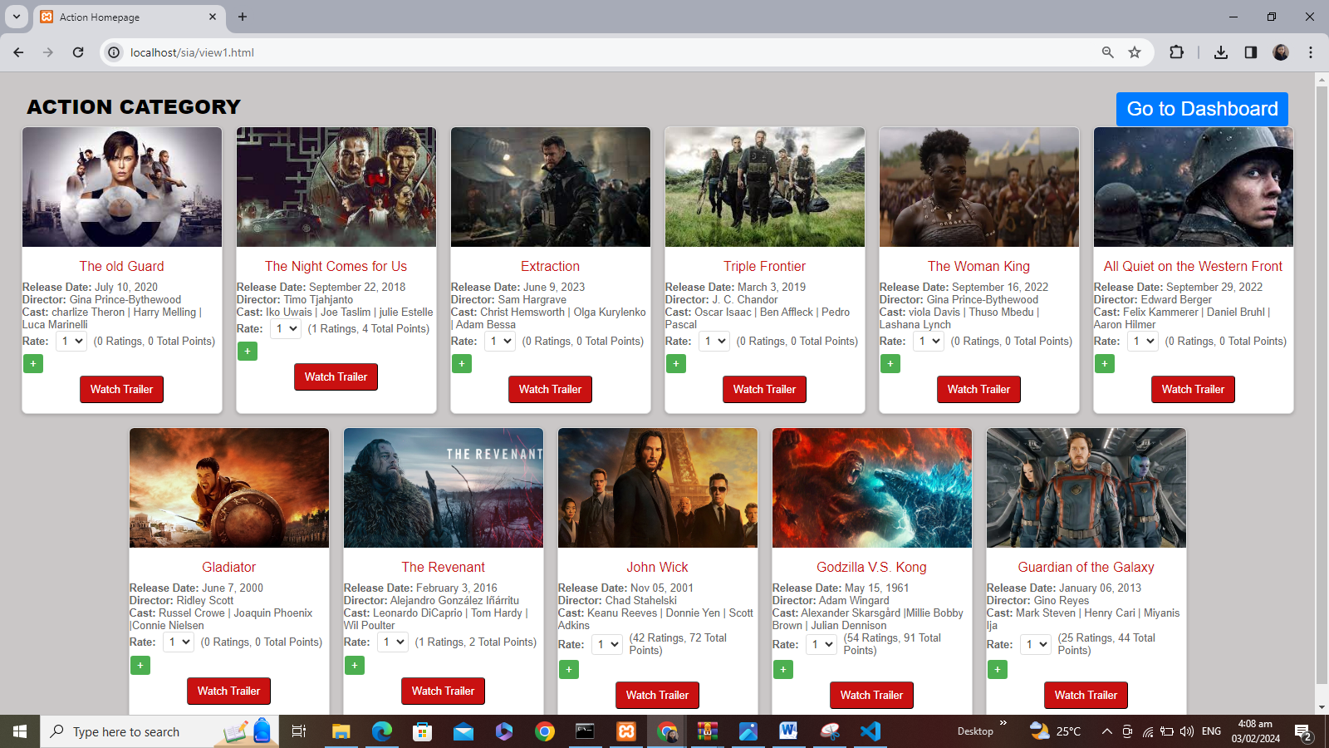

User Anime Category:  
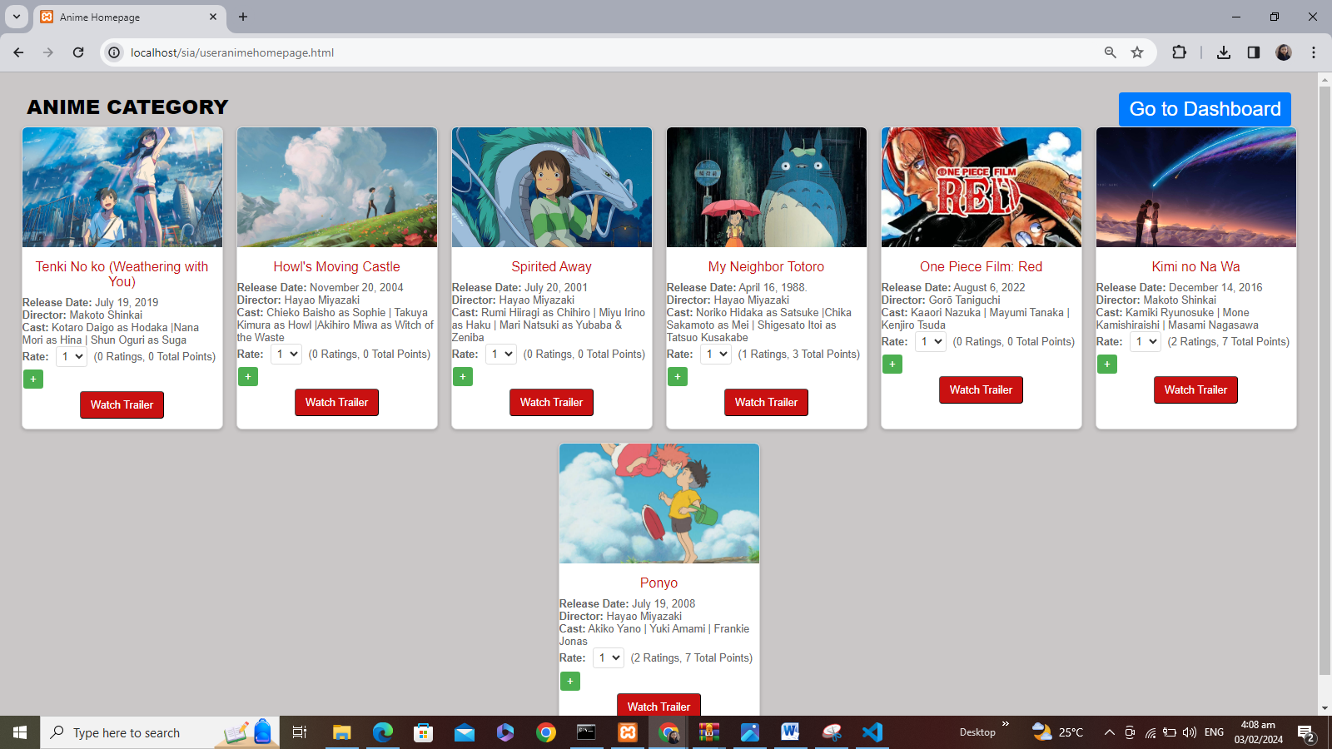  
  
User Tragic Category:  
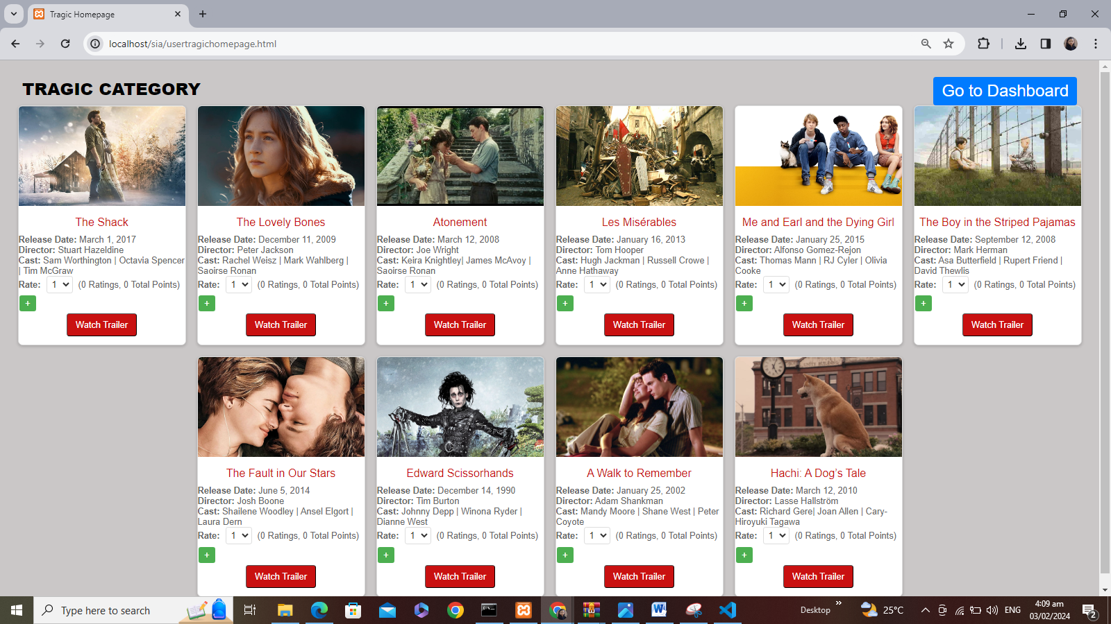  
  
User Documentary Category:  
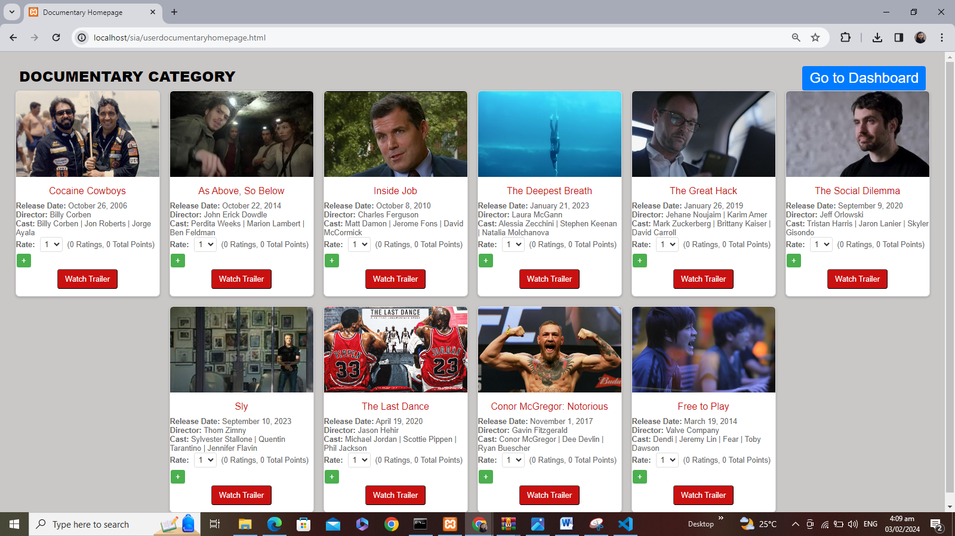  
  
User Drama Category:  
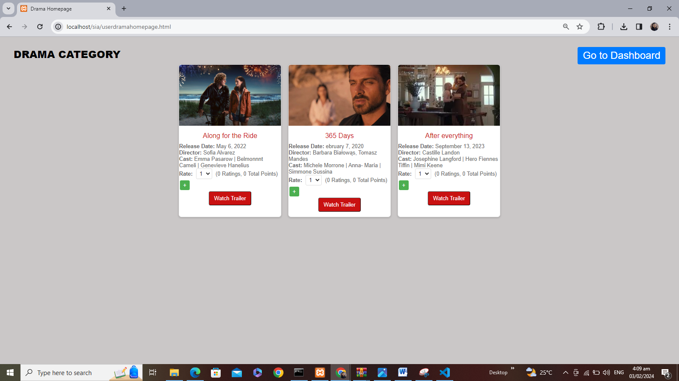  
  
User Sci-Fi Category:  
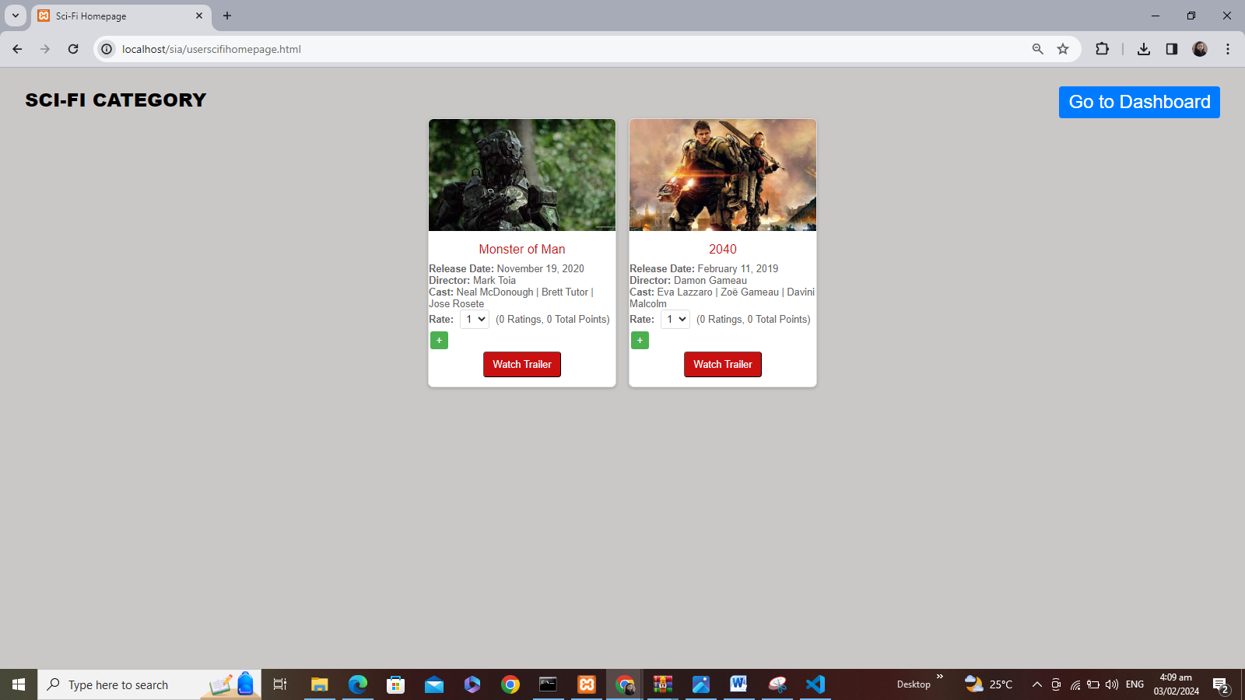  
  
  
User Library(When blank):  
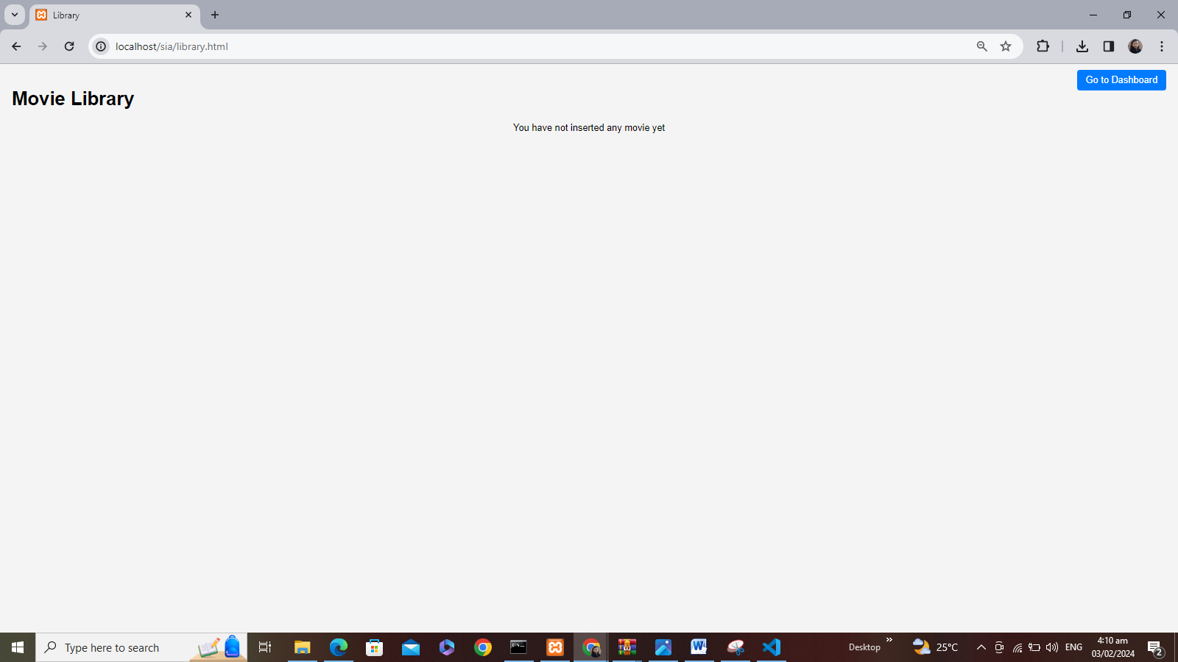  
User inserting card functionality:  
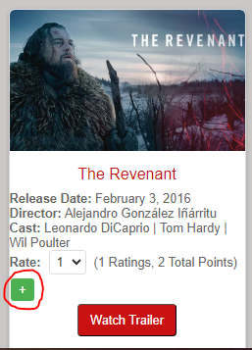  
  
Updated user library:  
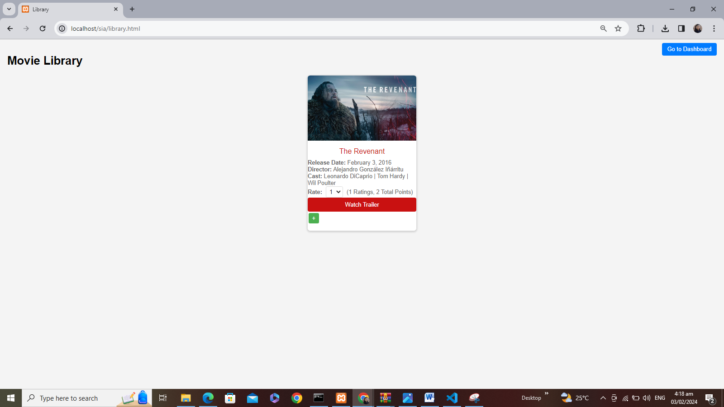  
  
Updated Database:  
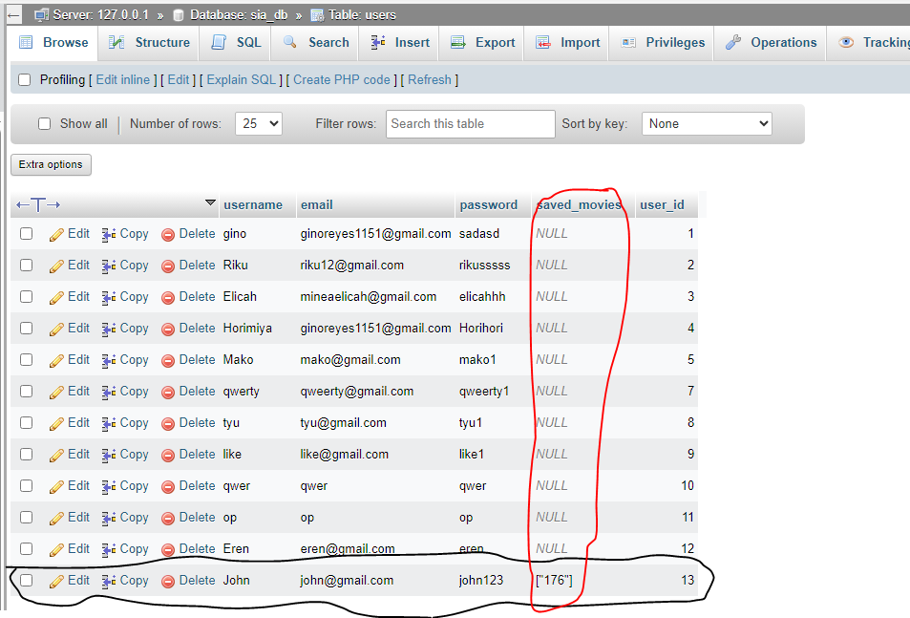  
  
User Total Ratings:  
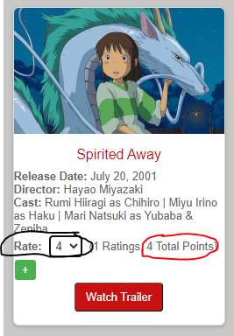  
Movie RatingDatabase:  
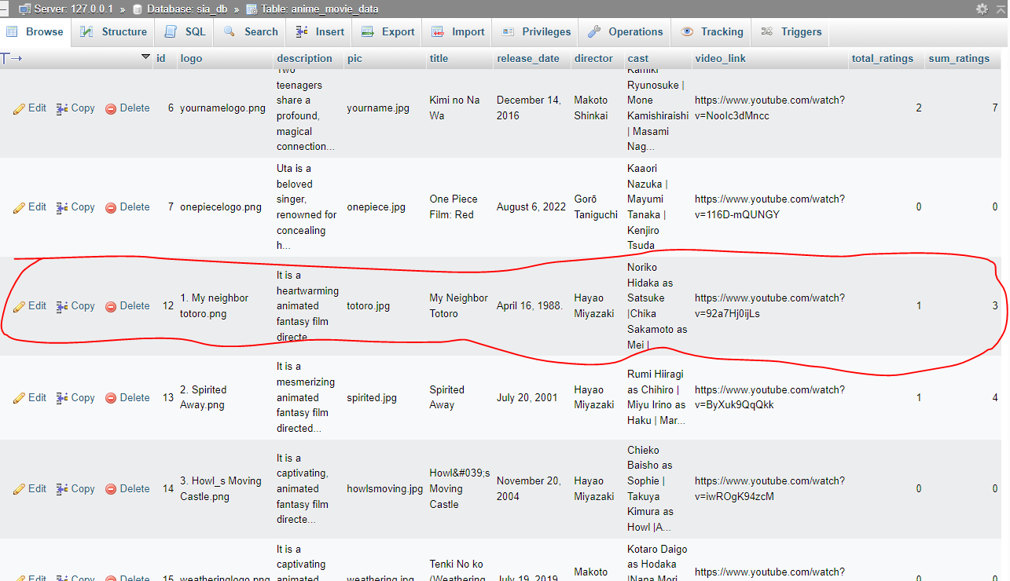

Youtube API Integration:  
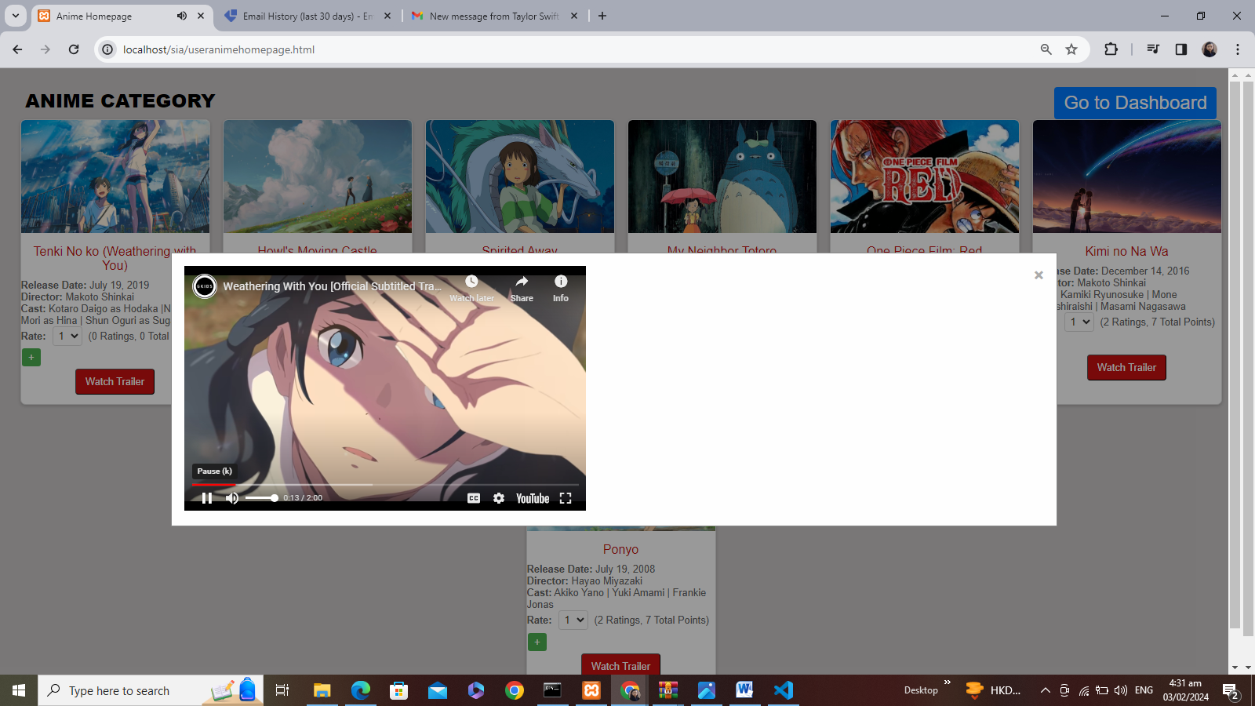

Contact Us:  
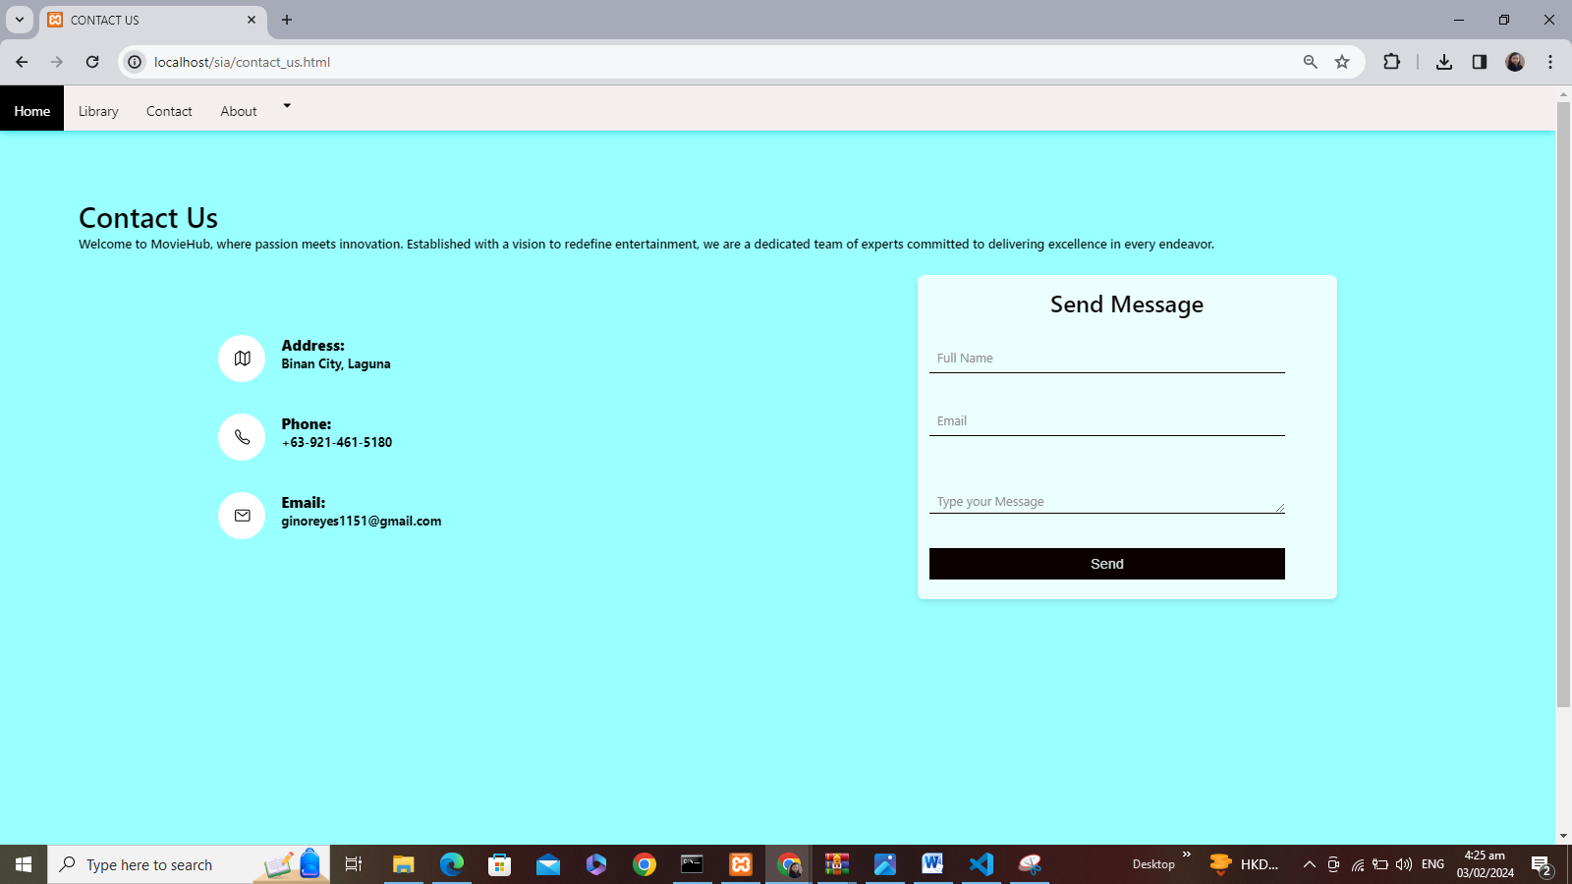

Contact Us Functionality (Integrating EmailJS API):

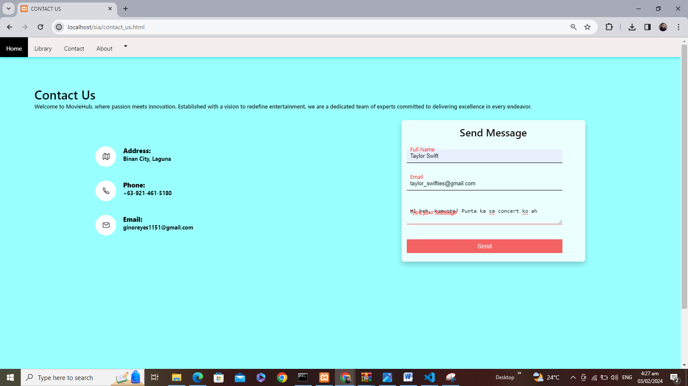

Output:

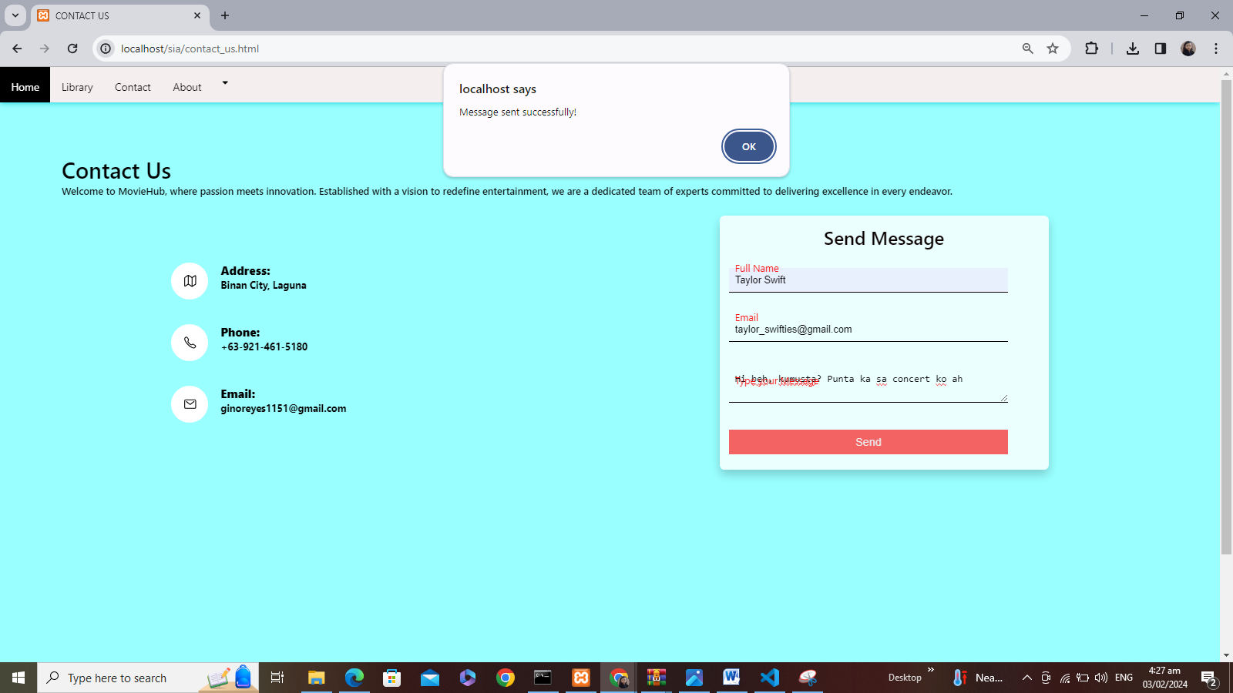

Email received on admin email(Gmail):  
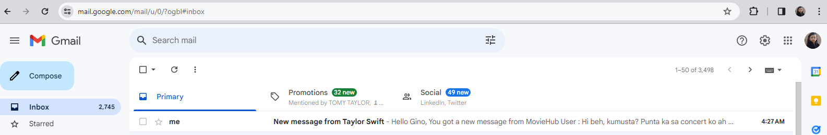  
  
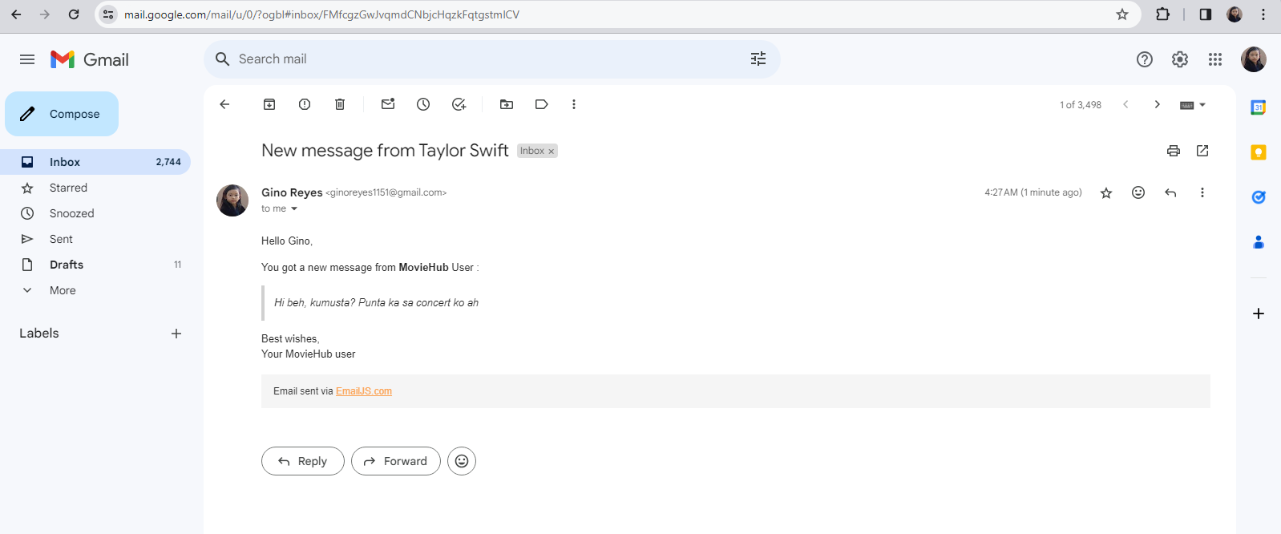  
  
Template Parameter by EmailJS API Integration:  
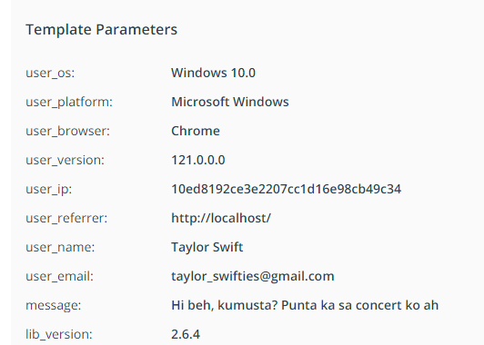

About.html:  




Sign up as admin:  
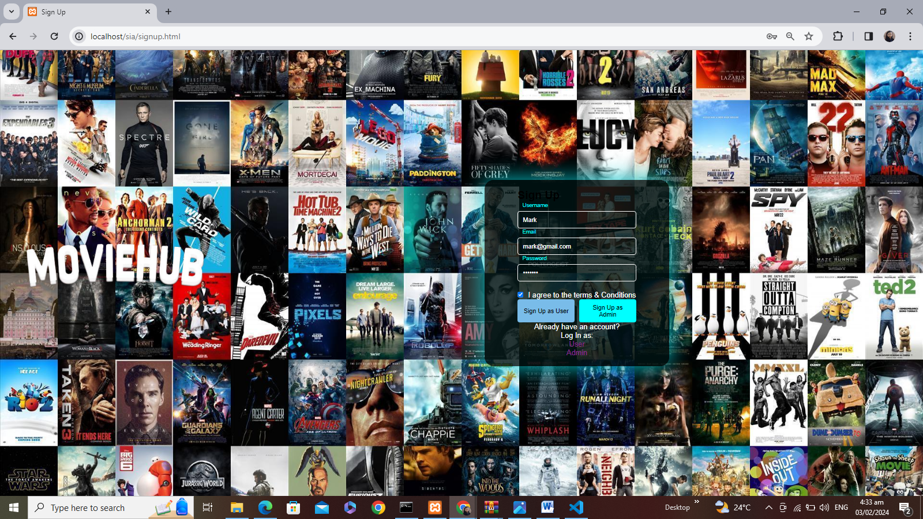

Admin database:  
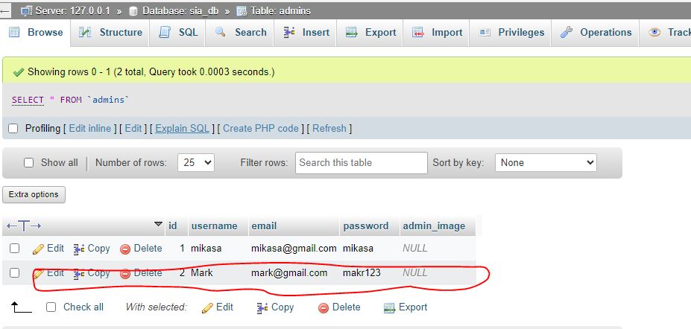  
  
Login as admin:  
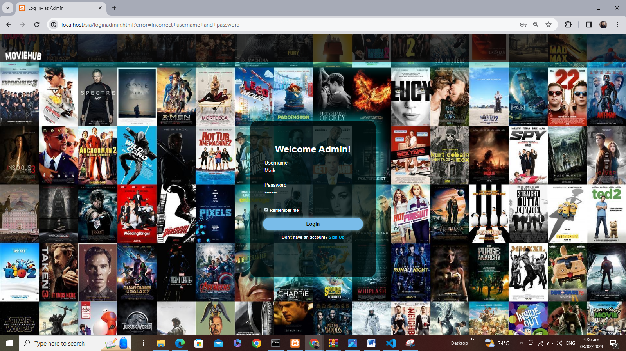

Admin dashboard:  
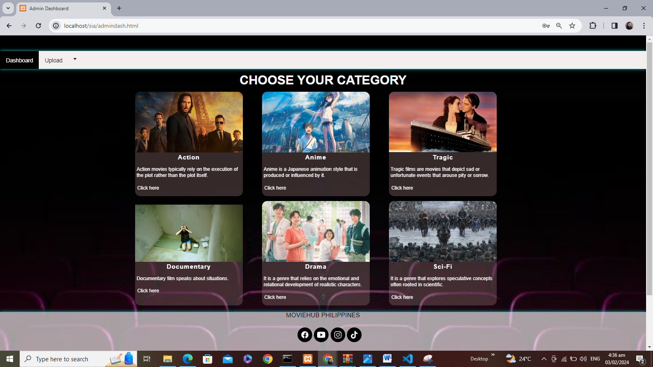  
  
Admin view of Action Category:  
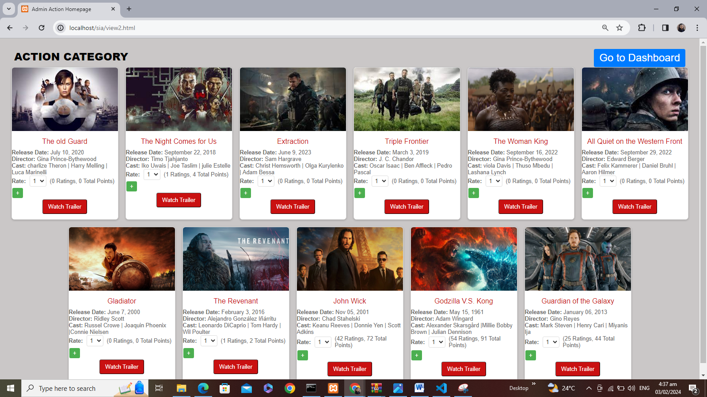

Admin view of Anime Category:

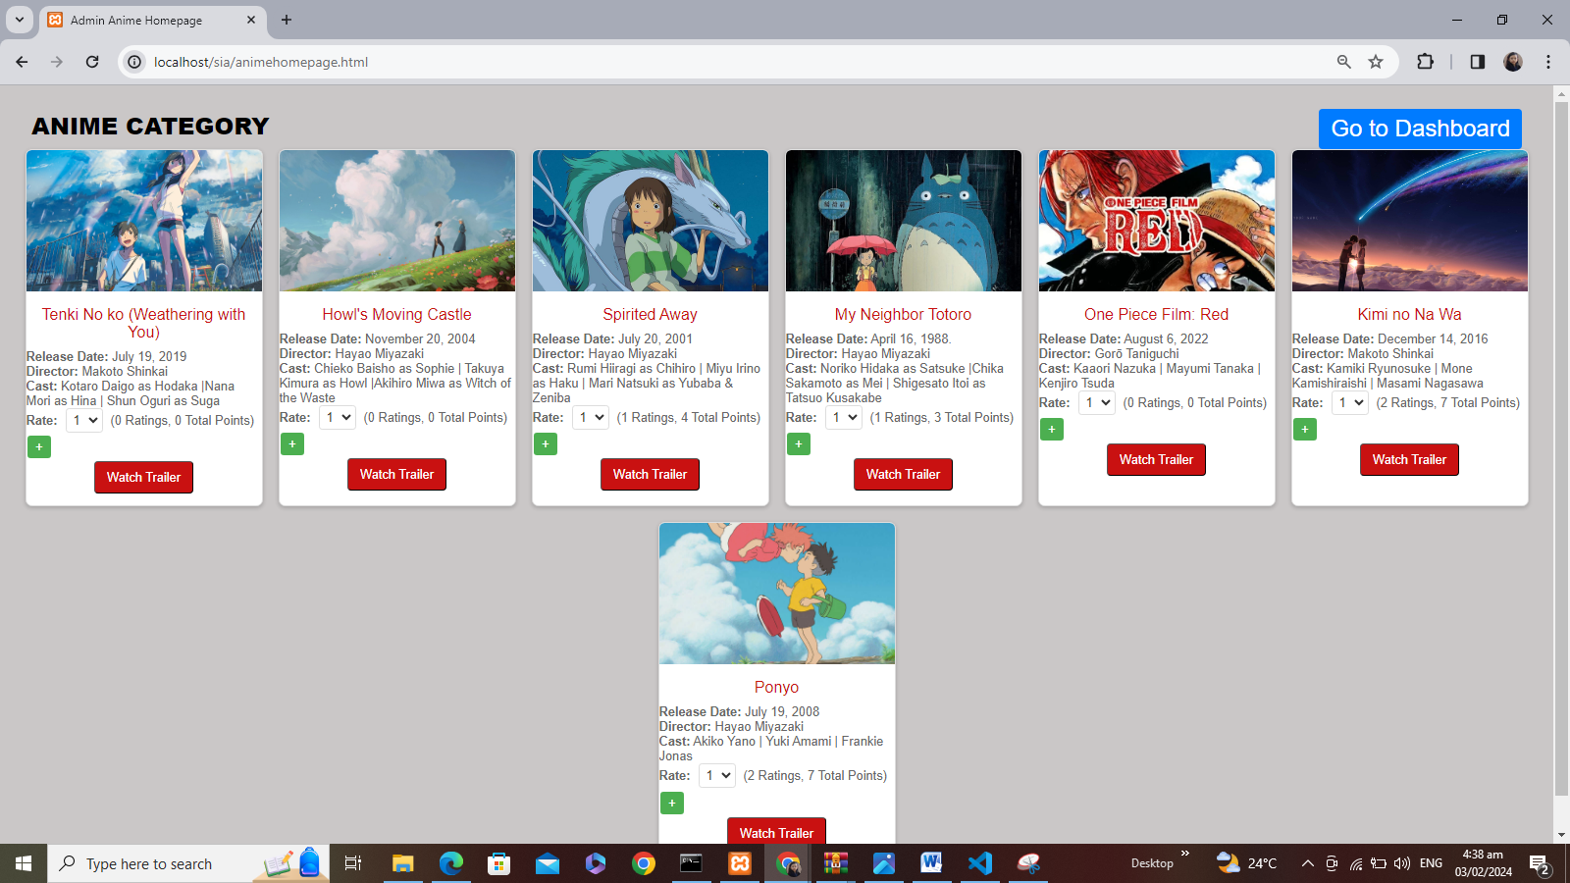  
  
Admin view of Tragic Category:

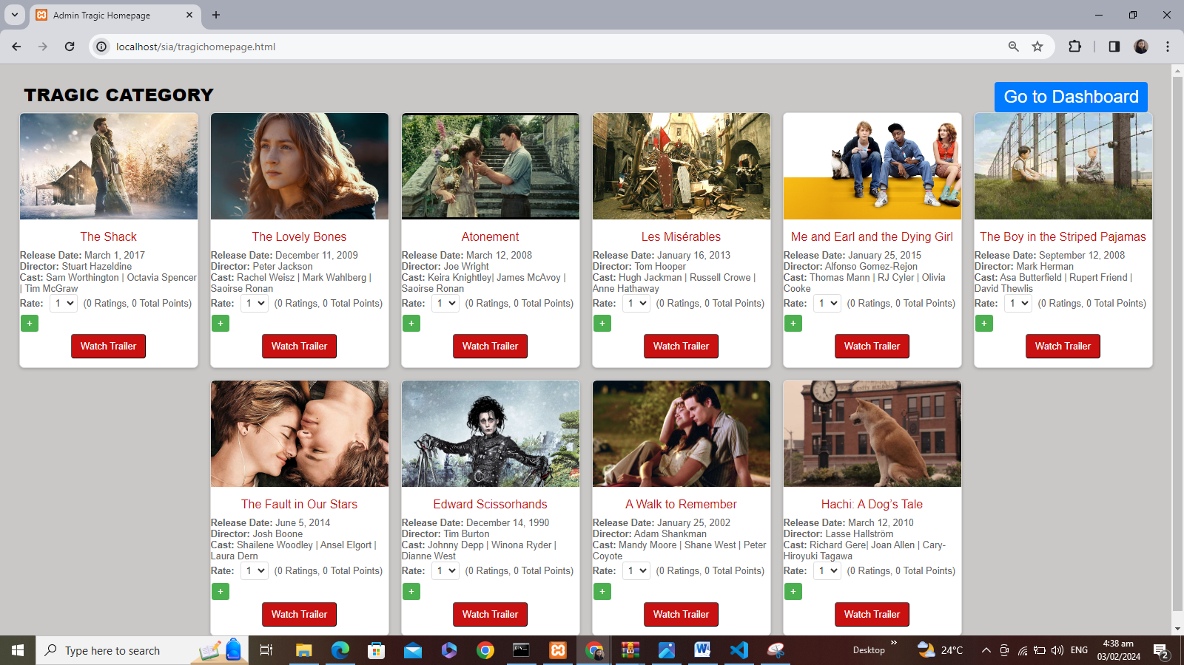

Admin view of Documentary Category:

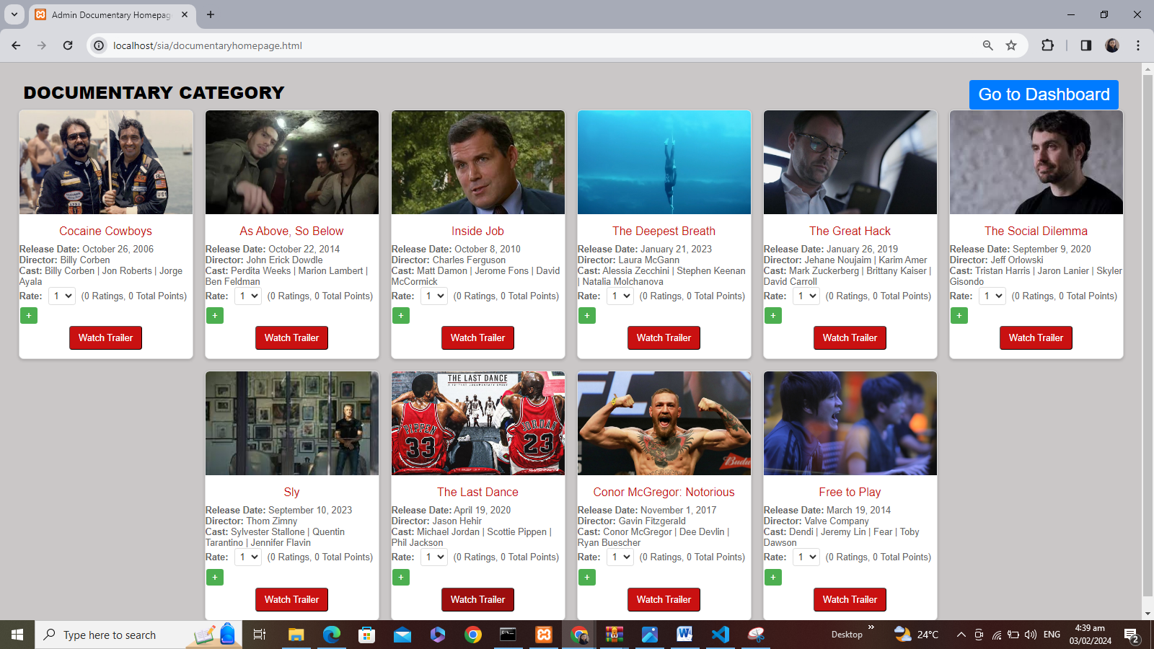

Admin view of Drama Category:

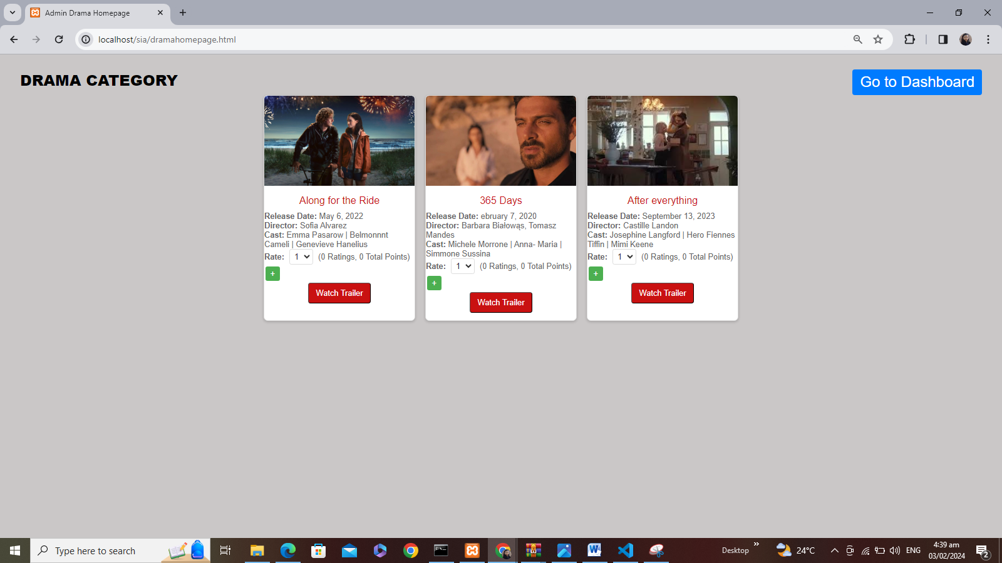

Admin view of Sci-Fi Category:

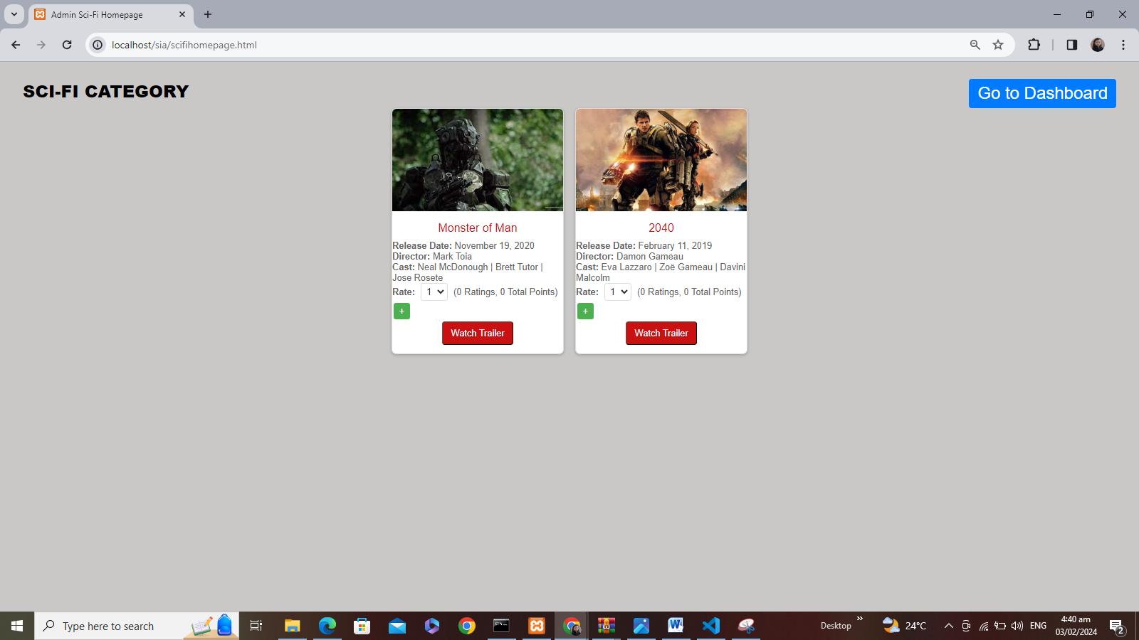  
  
  
Admin Upload:  
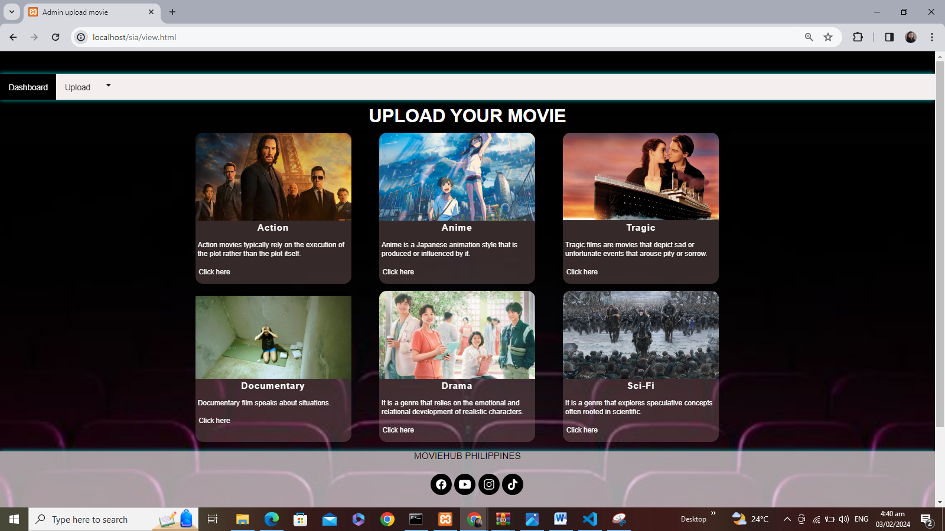

Action Upload:  
  
  
Uploading new action movie:  
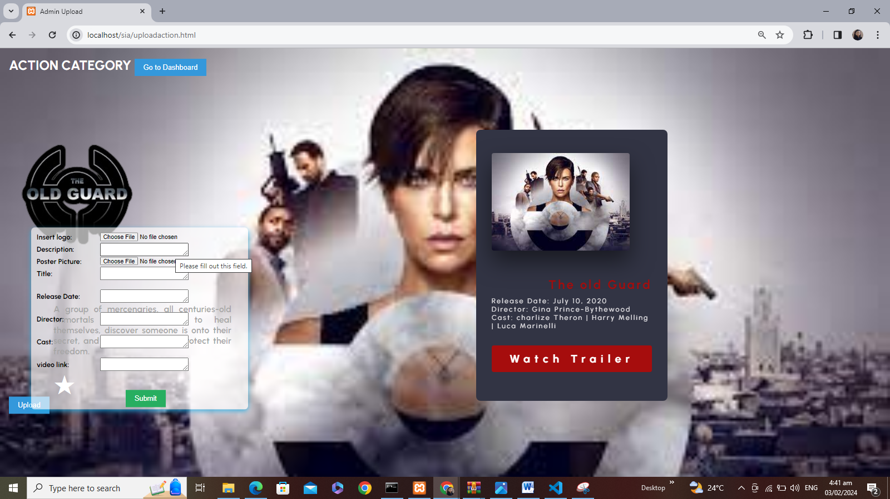

Anime Upload:  
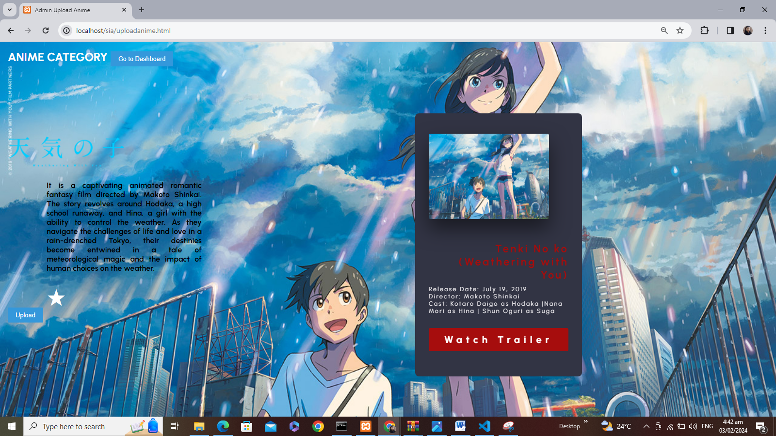

Uploading new anime movie:  
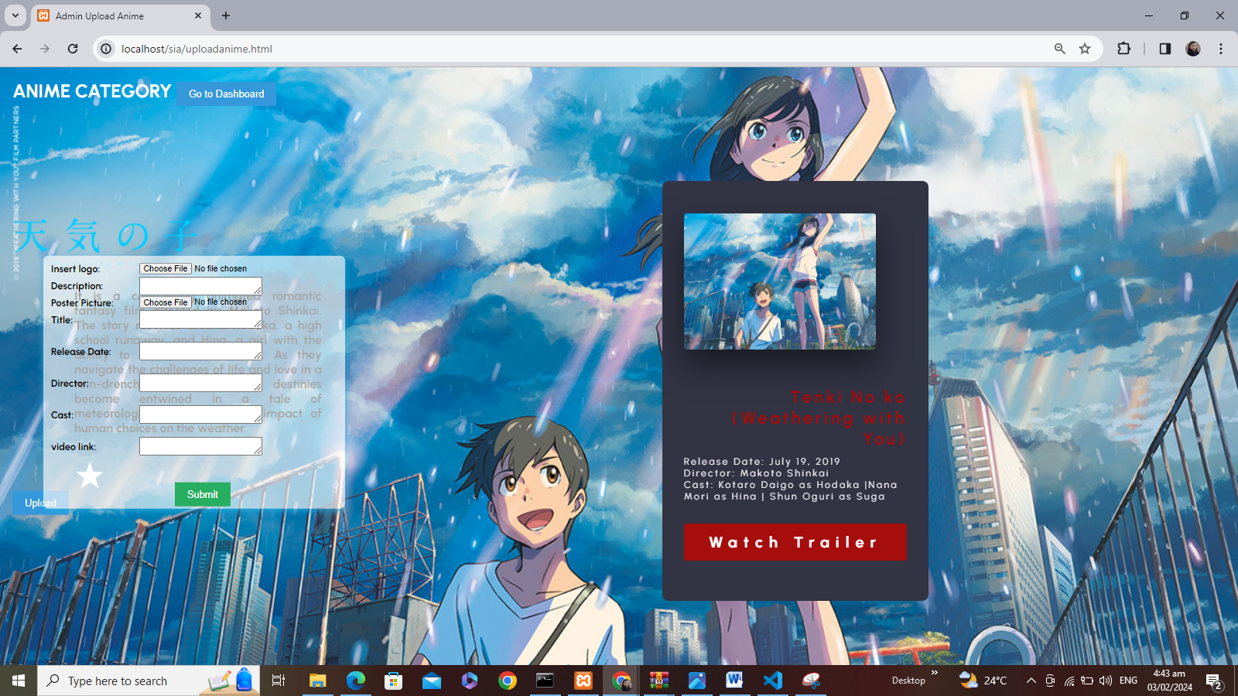

Tragic Upload:  
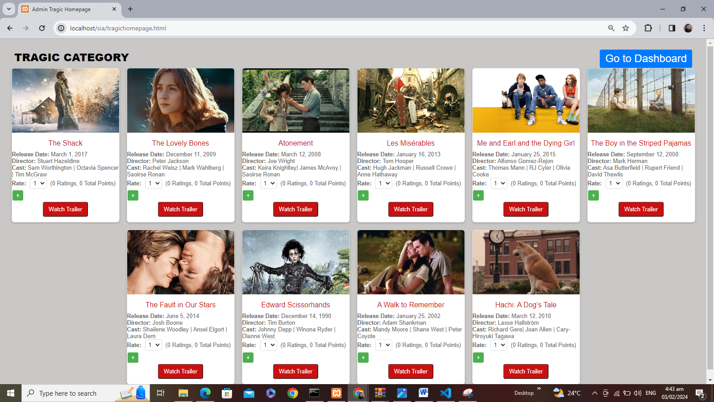  
  
Uploading new tragic movie:  
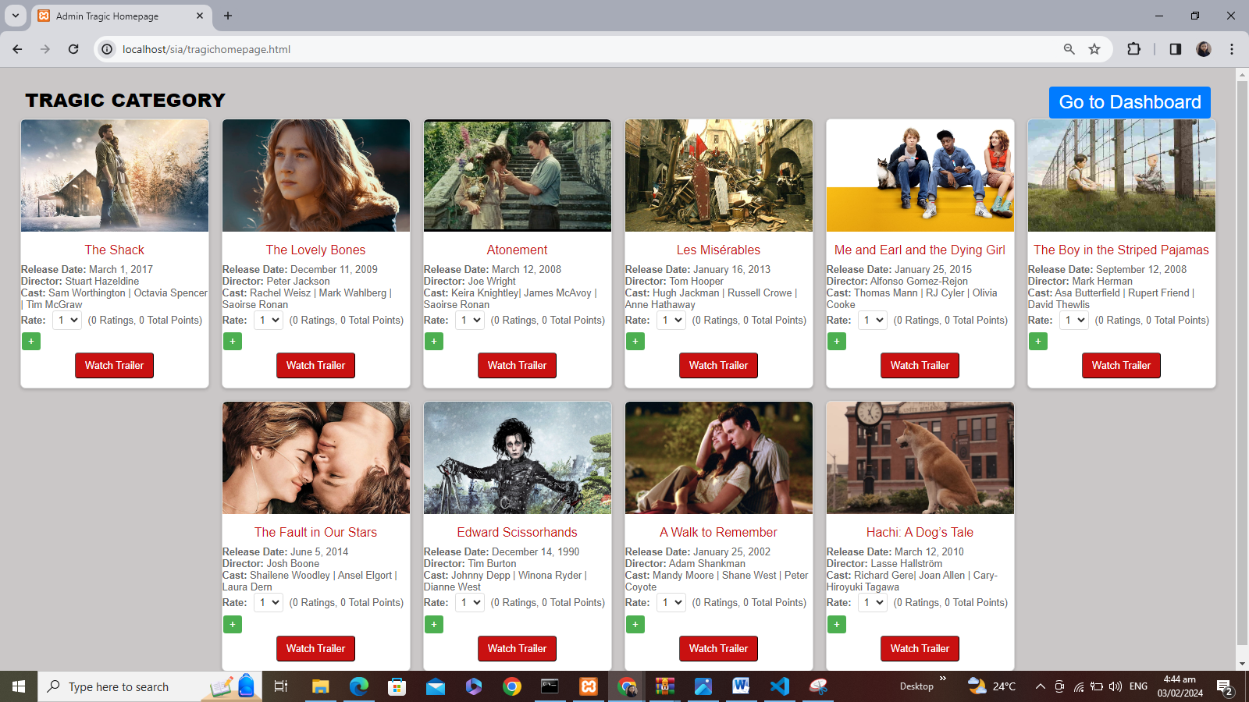

Documentary upload:

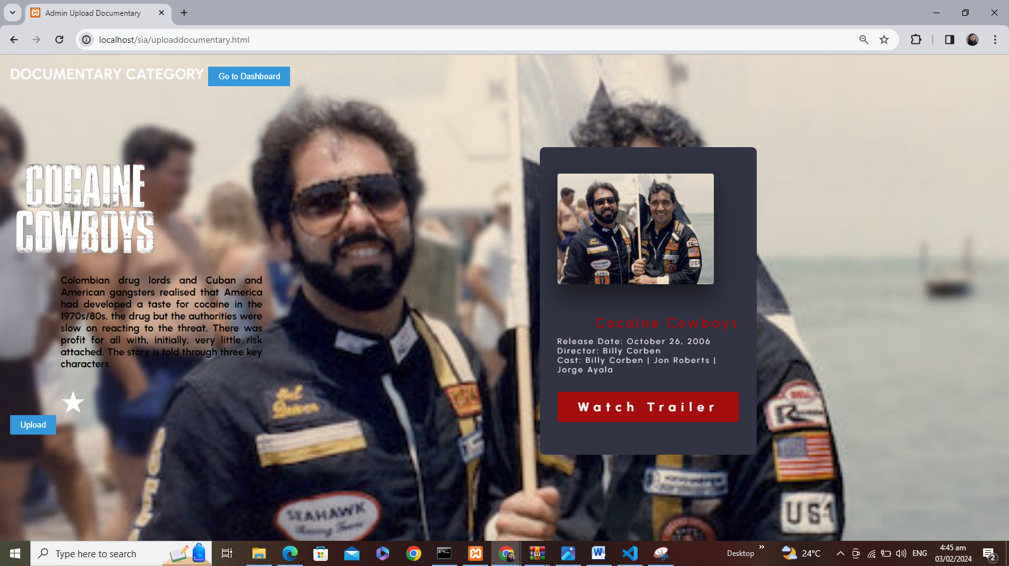  
  
Uploading new documentary video:  
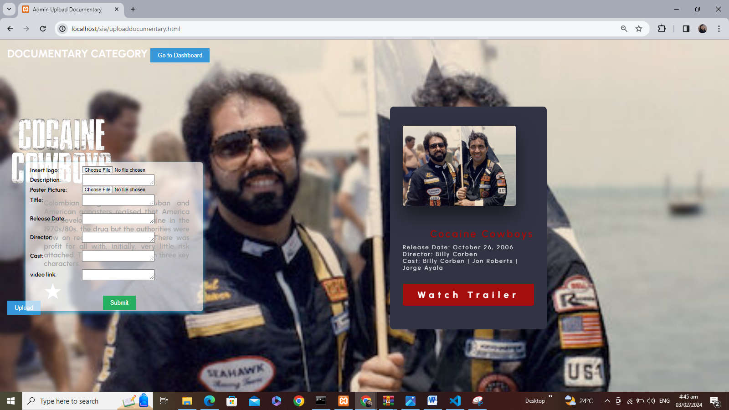

Drama upload:  
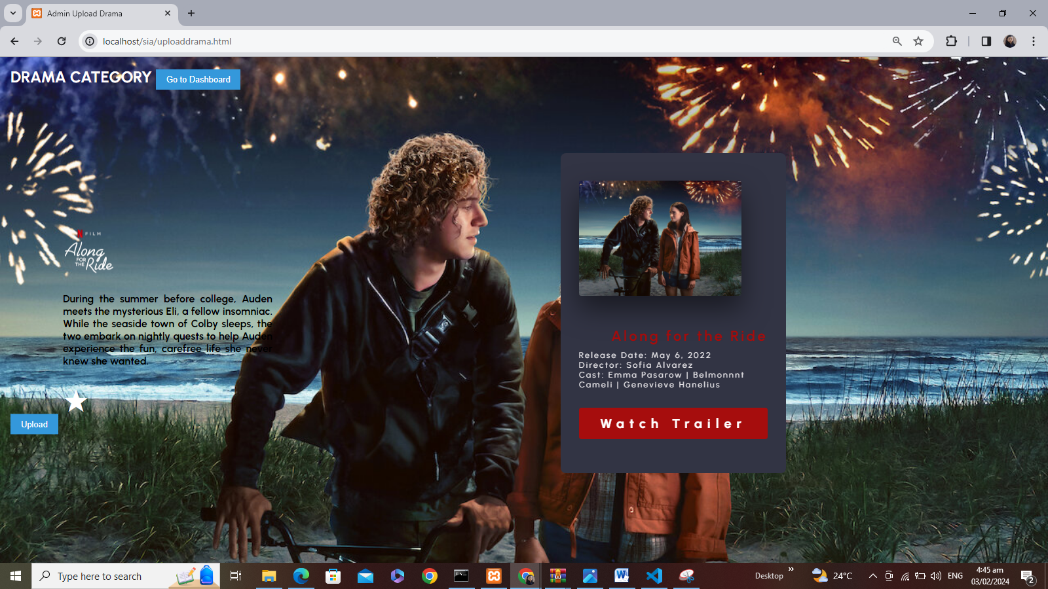  
  
Uploading new drama movie:  
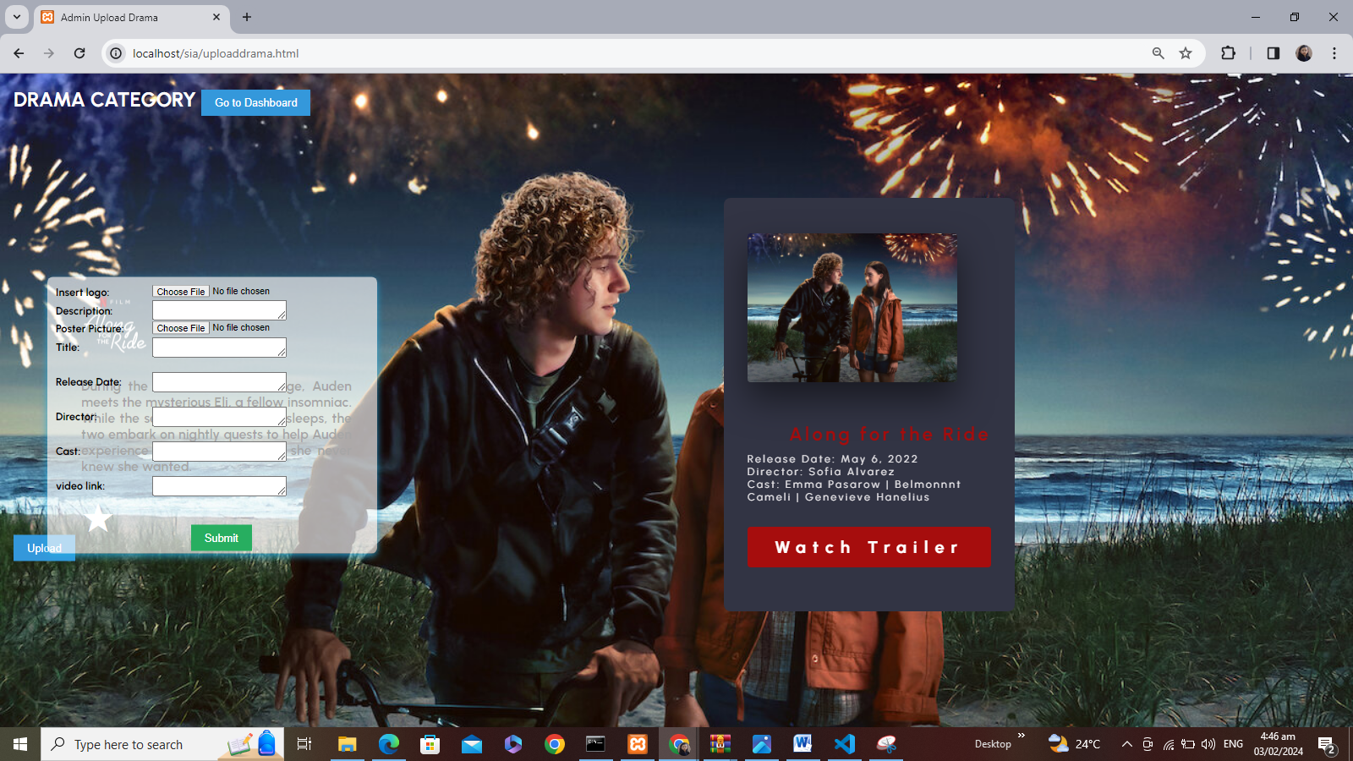

Sci-Fi Upload:  
  
  
Uploading New Sci-Fi Movie:  
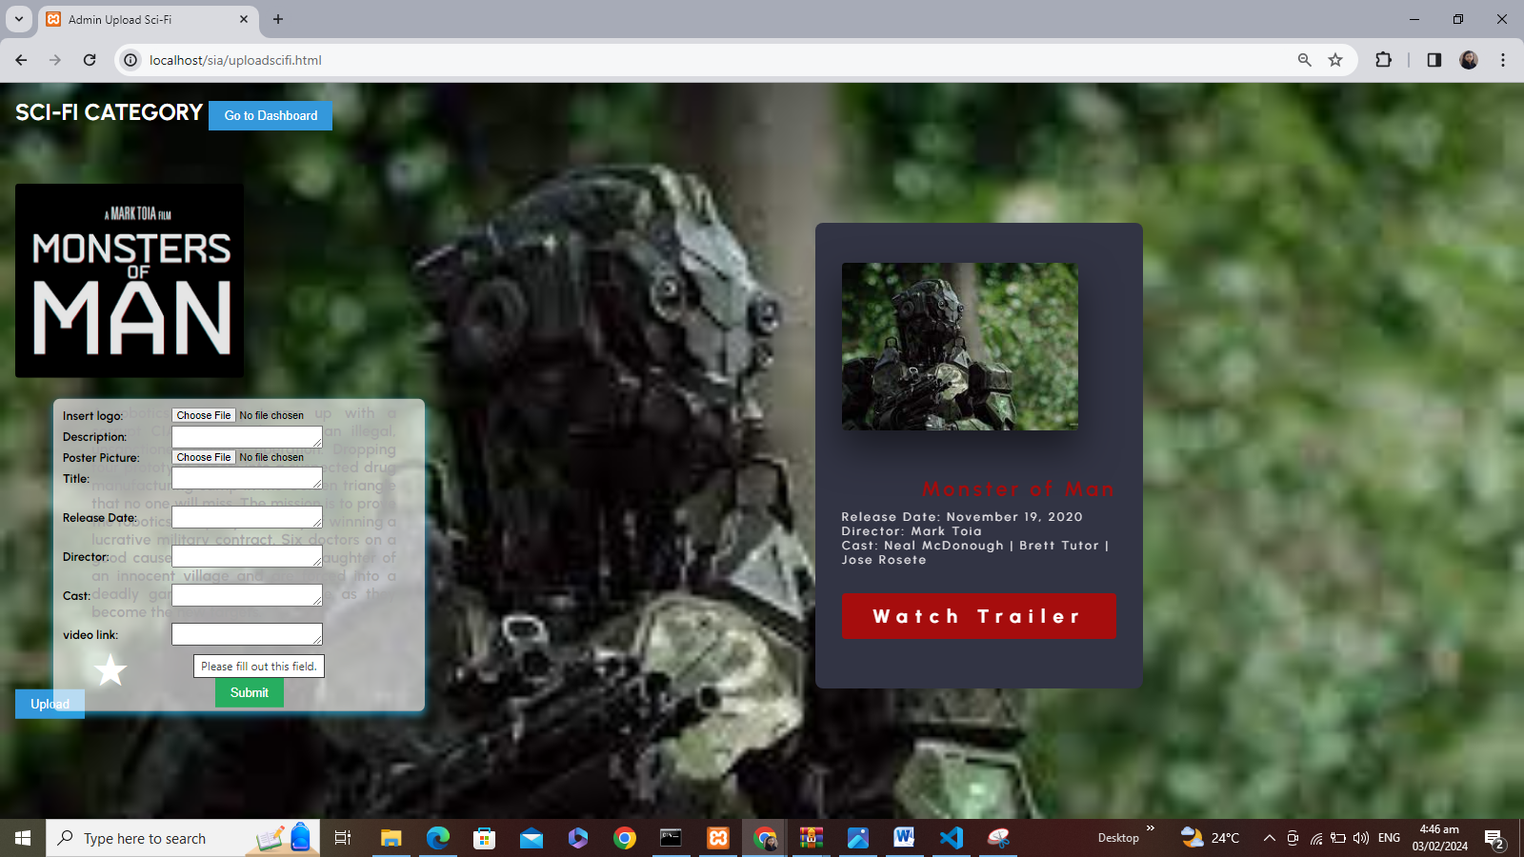

Here’s how does the system work:  
  
ADMIN’S POV (UPLOADING NEW VIDEO IN TRAGIC CATEGORY):  
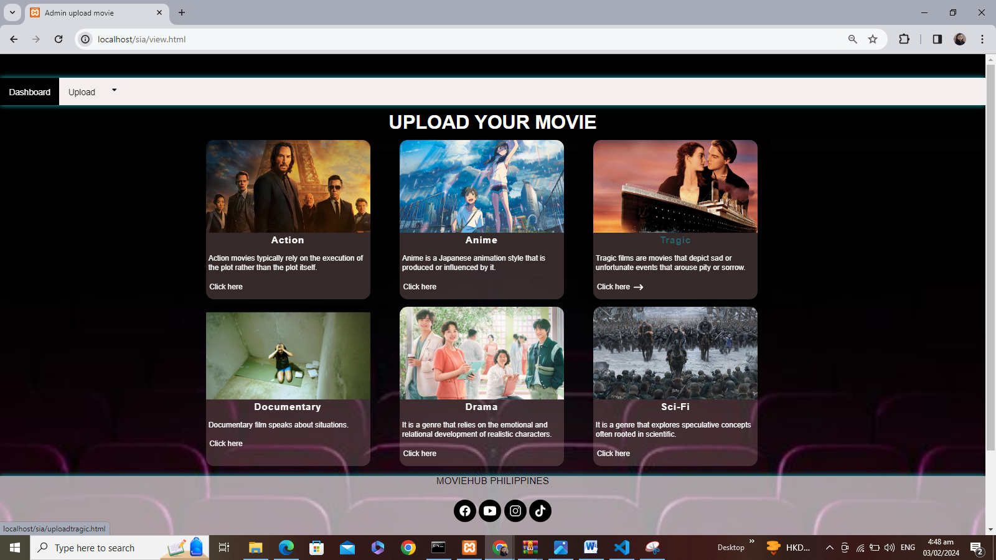

**Before Uploading**: As you can see, the data and ready to upload including movie logo, description, poster picture, title, release date, director, cast, video link (I chose **Titanic movie** to be inserted)

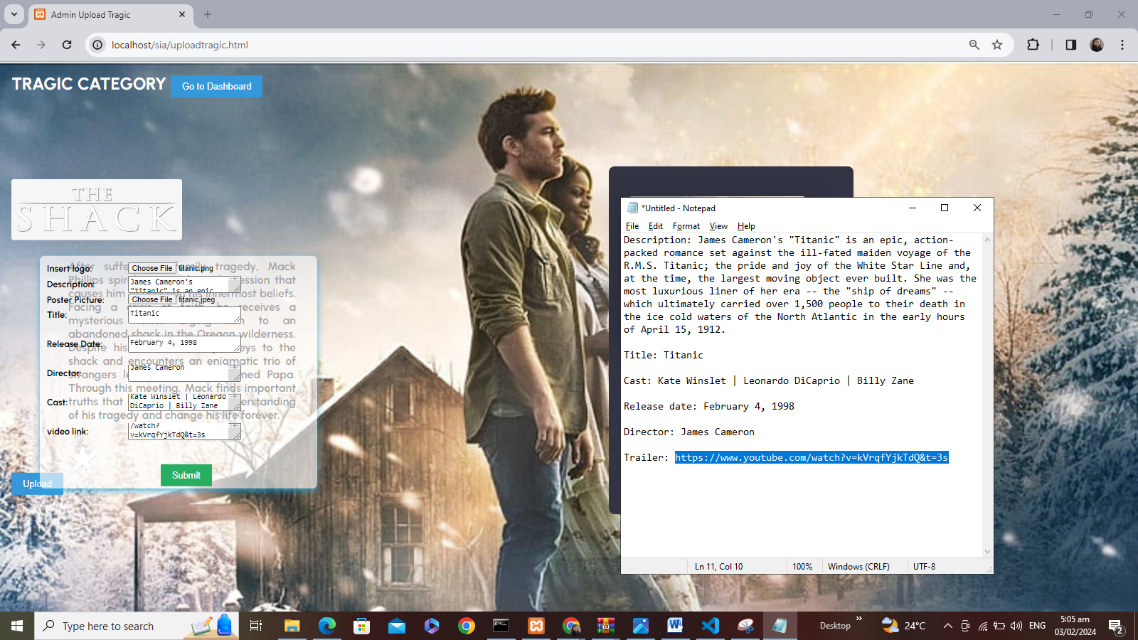

**After Upload**: The data is generated into cards, setting different data saved from database sia_db and fetched to display new data into same format and created template:  
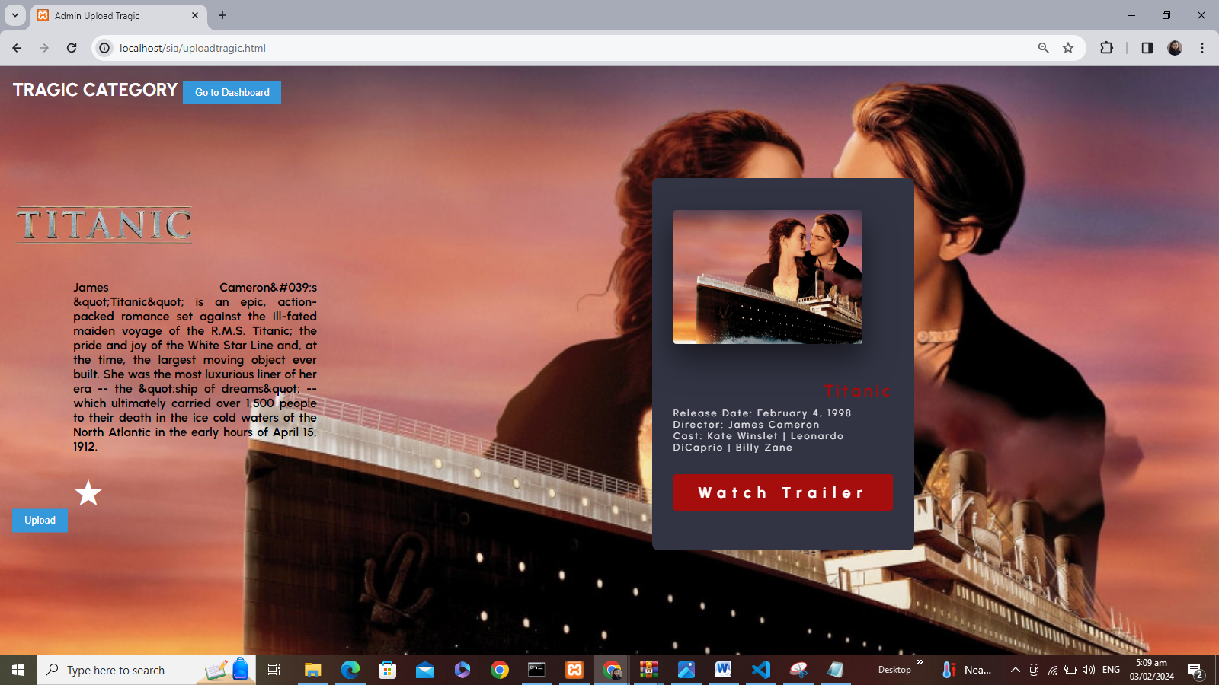

ADMIN POV in Tragic Category list:  
**(BEFORE):** 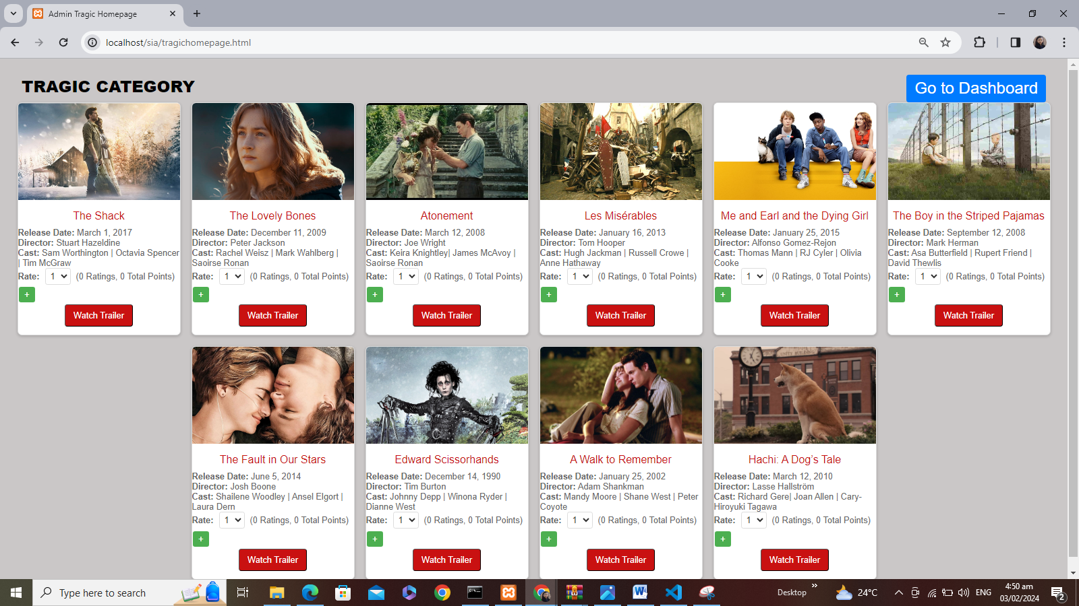

**(AFTER):**Here the Titanic video is already updated and generate a new card in Tragic category:  
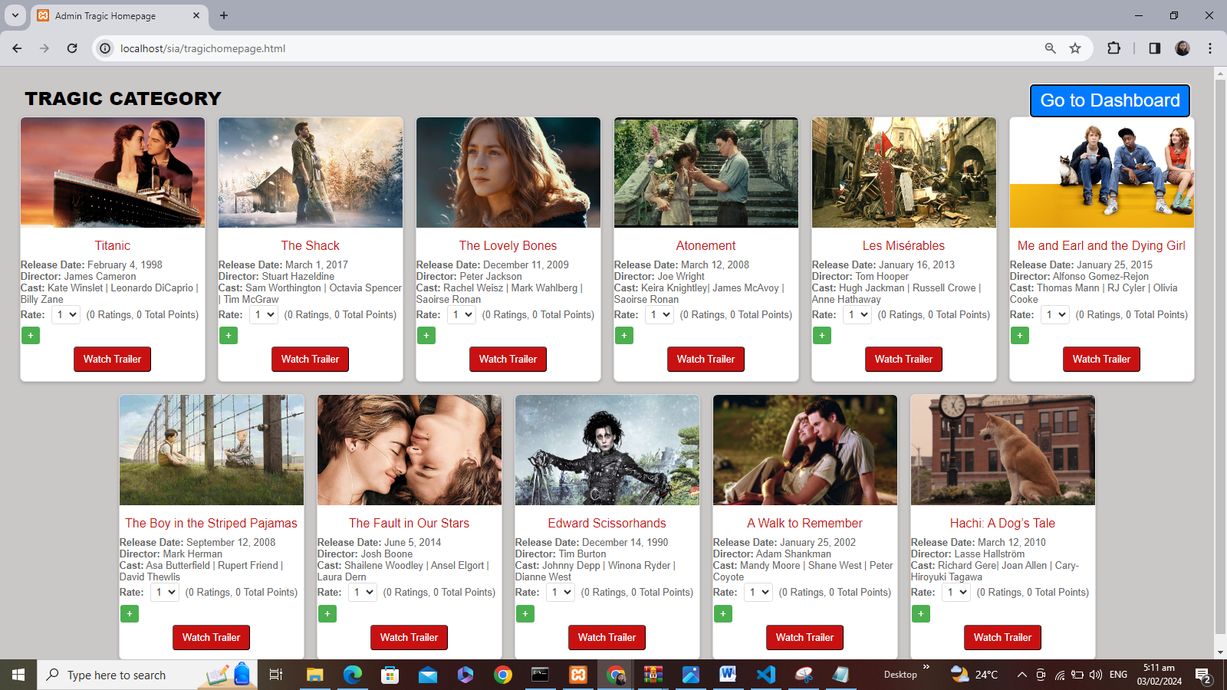

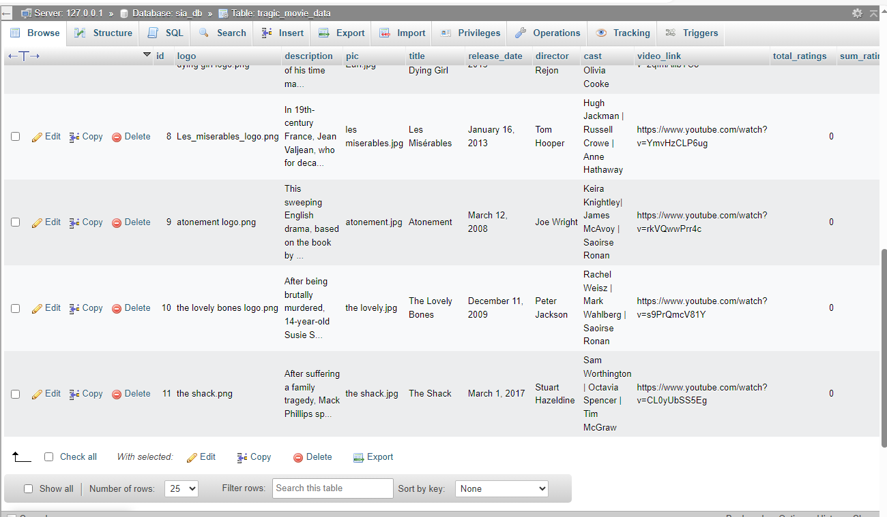Tragic Movie Database:  
**(BEFORE):**

**AFTER):** the Titanic movie data already inserted in database:  
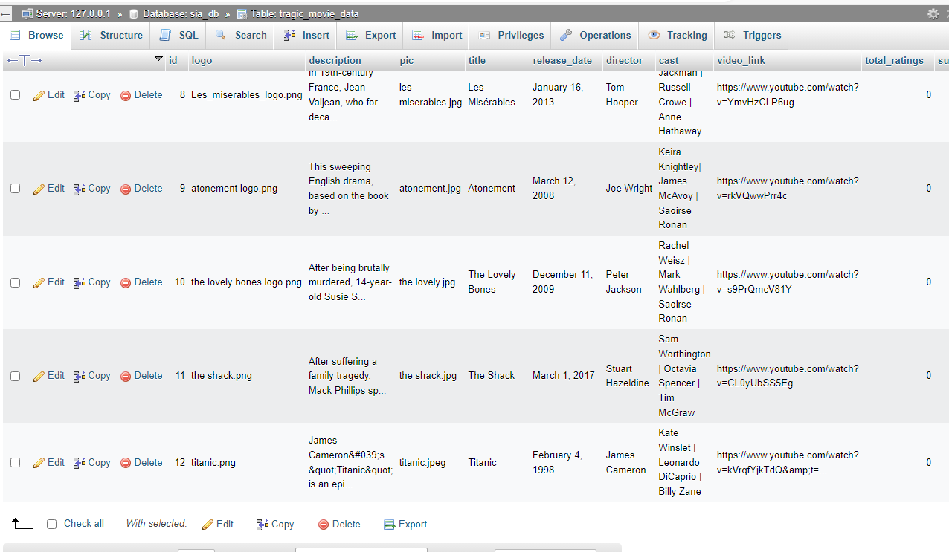

**(BEFORE):**

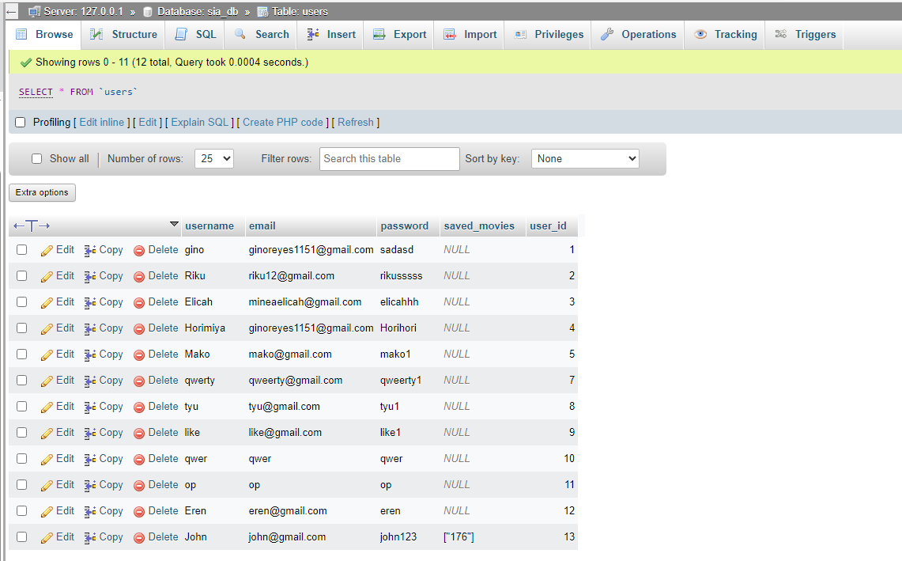Username: John (saved_movies) data, have only 1 movie card in library

**After** clicking another card to add in the library using button in Action Movie card data:

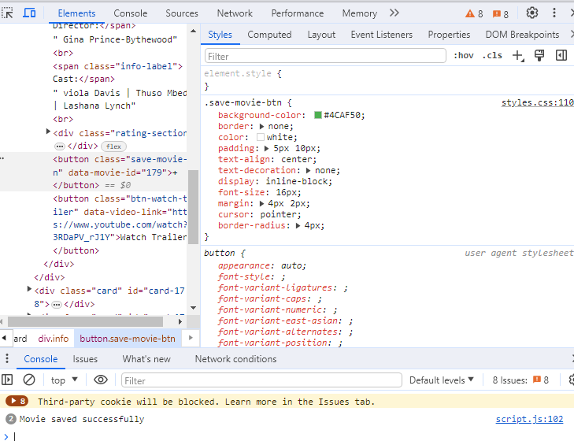

From above display, I set the console log in php to notify if the data is already saved and fetched from database to library.

Username: John saved_movies successfully saved the new card data of The Woman King which is “**179”**  
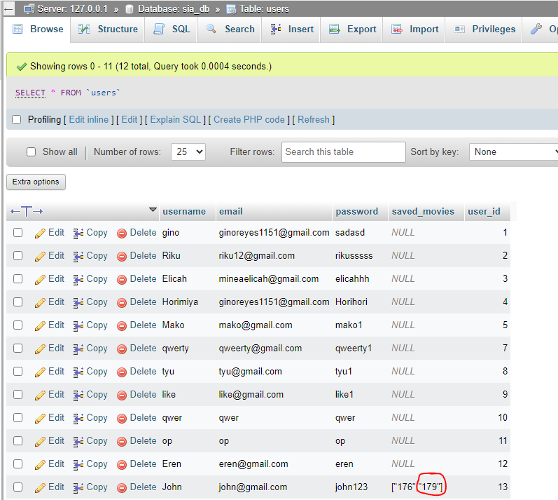

USERNAME: John’s Library data

**(BEFORE):**

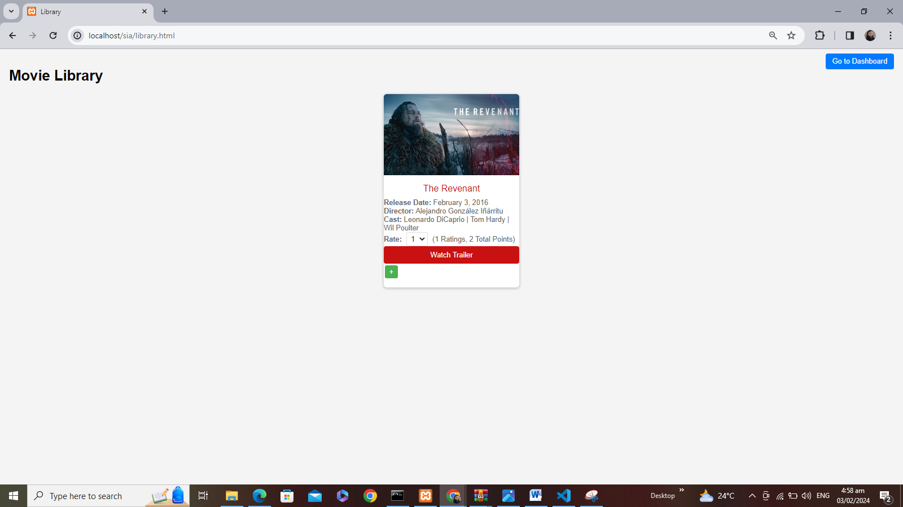

**(AFTER):**

